**Assignment 12**

**KD1-Indrajeet-86641**

Q1. Write a query that selects all customers whose ratings are equal to or greater than ANY of Serres’.

🡺 **select * from customers**

**where rating >= any(select min rating from customers, salespeople**

**where customers.snum = salespeople.snum and sname = 'Serres');**

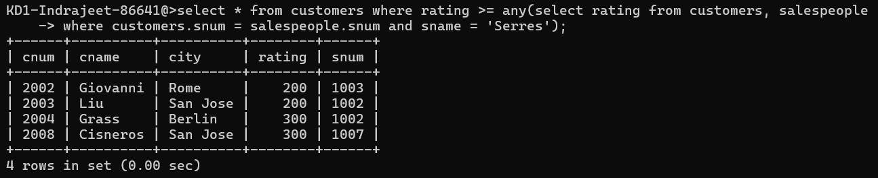

Q2. Write a query using ANY or ALL that will find all salespeople who have no customers located in their city.

🡺 **select sname from salespeople, customers where salespeople.city**

**NOT IN ( select city from customers) and**

**salespeople.snum = customers.snum;**

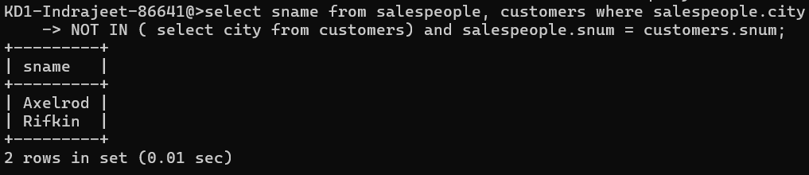

Q3. Write a query that selects all orders for amounts greater than any for the customers in London.

🡺 **select * from orders where amt> ANY ( SELECT amt FROM orders**

**WHERE cnum IN ( SELECT cnum FROM customers WHERE city='London' ) );**

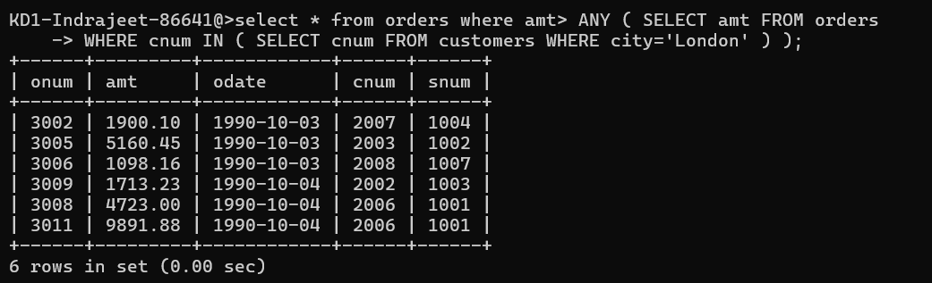

Q4. Write the above query using MIN or MAX.

🡺 **select * from orders where amt> ( SELECT min(amt) FROM orders**

**WHERE cnum IN( SELECT cnum FROM customers WHERE city='London' ) );**

